Cross-Same-Class Autoencoders for Improved Latent Space

Arthur Lubambo
Student Master of Science (MSc) in Data Analytics
CCT
Dublin, Ireland
sbs231001

Abstract— Autoencoders are widely used as a non-linear dimensionality reduction method, as an unsupervised method the latent space might not be good enough for a particular task. This paper proposed a semi-supervised learning method Cross-Same-Class-Autoencoder (CSC-AE) aiming improve their ability to produce latent spaces with enhanced class separability. The CSC-AE utilizes a data augmentation strategy that incorporates not only the same signal as input and output like Traditional Autoencoders. It was made a comparison between the proposed method and the traditional it was found improvements in F1-Score and Rand Index using Dense-Autoencoders applying it with handwritten digits from the MNIST dataset. Although further experiments are needed in the area to validate this technique.
Keywords—Semi-Supervised Learning, Autoencoders, Latent Space, Dimensionality Reduction

Introduction
Unsupervised Learning is a sub-area of machine learning where the data analysed is not labelled. In other words, the input instances from the learning algorithms don’t use feedback from any output. For instance: Clustering and dimensionality reduction are two common examples of this types of tasks in Unsupervised Learning (Ghahramani, 2004).
The Autoencoder is an Unsupervised learning method proposed by (Kramer, 1991), used to tackle a dimension reduction named originally as Nonlinear Principal Component Analysis in the article. Many years later It was quite used in deep neural networks, enabling applications processing tasks involving image/audio/media which transforms non-linear and high dimensional data into compressed dense vectors, or tensors. This type of neural network architecture is composed by an encoder and decoder. The Encoder maps the input signal into a vector lower dimension comparing it with the original input (bottleneck). The vector belongs to the latent space. While the decoder makes an opposite task, it maps the vector into the output signal. During the Autoencoder training the network has the weights adjusted applying the input and output with the same signal.
The Encoder Layer is quite useful because it is possible to convert multiples complex signals into a set of vectors. Making tasks such as calculating similarities, distances, interpolation, and other operations quite straight forward.
The Decoder Layer is also being used in Generative Artificial intelligence (GAI) to create new Output Signals from Latent Space.
The focus of this project will not be on GAI. Instead, It will target make a comparison in the quality of encoders between Traditional Autoencoders (TAE) and Cross-Same-Class Autoencoders (CSC-AE), in relation to which of them produces latent with better separability of classes.
The Cross-Same-Class Autoencoder proposed in this paper, uses a Data Augmentation technique that will not only train the Autoencoder with the same signal as input and output, instead it trains using a combination of same class signals, but not necessarily same instance.
This method can use a combination of labelled data with un-labelled data (Zhu, 2005), making it a semi-supervised learning algorithm.
Note the goal of this strategy is to influence the latent space to put the instances of the same class closer to each other and enforce the Encoder Layer to extract and learn meaningful features to create a latent space capable to discriminate between the classes.
Why it is important? There are multiple problems in the world dealing with high dimensional data. Images, Videos, Audios, Text, Signals, Sensors. It is very common to have non-linear data involved in this area, making typical principal component analysis (PCA), Factorial Analysis, and other linear techniques not very efficient. (Box et al., 2009)
This project aims to compare a proposed technique to train autoencoders called Cross-Same-Class-Autoencoders with Traditional Autoencoders. The task target here is the quality of the latent space produced from the encoder. It will compare separability of classes in the latent space produced from both types of autoencoders. For Demonstration purpose it was used the handwritten digits from the MNIST dataset (LeCun, 2009) as an example, using two different architectures of Autoencoders: Convolutional Autoencoder and Dense Autoencoder.
The structure of this paper has Introduction to the problem and area of study, then Related works referencing different applications of Autoencoders, also Big Data technologies used by other authors, in the Methodology is possible to find details about the proposed technique how the experiments were executed. Then, in the Results it will be explained how the evaluation metrics were calculated, and values, also it will be demonstrated using data visualization of sample traditional technique and the one proposed in this project, the Discussion chapter will analyse the founds and how they contrast with the expected results. And finally, the Conclusion where it will be summarised the key findings and highlight opportunities for future works in the area.

Related Work
Autoencoders could be used for a wide different set of tasks from reduce the dimensionality of inputs, noise removal, apply transformations signals, embeddings. This project focus on the dimensionality reduction, embeddings usage of the autoencoders.
The Dimensionality Reduction can be used as intermediary step in techniques such as One-Shot Learning (Fei-Fei, Fergus and Perona, 2006). For example: it could be used in face recognition, training the model with faces from a dataset, and apply using a few images from labels and associate other algorithms into the from the latent space to another task. In face recognition context the test dataset might have classes that doesn’t exist into the training dataset. But with just a few examples we will be able to identify the closeness into the latent space for the respective points.
Note this type of problem might have an arbitrary large number of classes making the multi-class classifiers not a suitable solution. Also, there other common use cases for autoencoders to process signals, apply transformations, such as noisy removal, stacked operations (Kan et al., 2014) Trains the AE using input signals and output signals with different poses to learn how to process and adjust pose of images progressively, until it be aligned with the target.

In this article (Schroff and Philbin, 2015), It is covered how embeddings of images is useful to apply calculations of similarities, clustering, and distances in a compact euclidian space. It uses another technique to achieve it different from Autoencoders.
Also, in music autoencoders can be applied. For instance: in this article (Qiu, Li and Sung, 2021) the authors use 3D Convolutional Autoencoder to create a latent representation of MIDI files which is a musical representation of notes and on each time. This latent representation is learned from large datasets then it is applied as encoding layer to be used in other models for classification tasks. Similar with the mentioned previously, it can learn specific tasks with a small, labelled dataset.
The Big Data is term used with in different ways by multiple people and industries. But it was assessed by (De Mauro, Greco and Grimaldi, 2015) what would be a standard consensual definition and it was found the following one “Information assets characterized by such a High Volume, Velocity and Variety to require specific Technology and
Analytical Methods for its transformation into Value”. In general, it deals with technologies capable to scale horizontally, instead of vertically. The challenges of infrastructure for this scale of data, involves storage, processing, and networking. Traditionally the programs were centralized in a machine, that reads inputs process and give outputs. When it was necessary to scale up, the people used to get better machines, but very easily they can reach the barrier of vertical scaling, making costs too big, or impossible to reach. On the other hand, the horizontal scaling is based on ordinary machines, working together, with the big advantage of at some point the cost of scaling up is “linear” based in the number of the ordinary nodes, contrasting the high costs of vertical scaling.
For Storage, the most used open source is Hadoop (Borthakur, 2007), it follows the principal of “Moving Computation is Cheaper than Moving Data”. Instead of sending the data to a central place to be computed (it would be a bottleneck), it creates replicas of the computation and send to each relevant data node to be processed in distributed manner. Just the partial results are sent to other nodes to be aggregated produce the output, that might be also stored in a distributed way. It is distributed because the input/output and computation don’t belong to a single machine, instead it is a network of machines working together for a particular task.
In this project it can be found scripts used to load and process data from Hadoop File System
For Processing Data, as mentioned before it follows another paradigm of computing, instead of sending the data input to a central machine to be computed, it sends the computation to the data. It makes the way the programs are written a little different. In general, it uses more functions such as map reduce, instead of loops over the data in memory to process. To facilitate it, it was developed tools such as Apache Spark (Apache Spark, 2010). The Spark has multiple tools and abstractions on top of it, such as MLlib, Spark Streaming, GraphX, SQL.
During the development of this project, spark was used, but due limitations of not having Autoencoder Native into MLlib, associated to very slow performance to deploy in a single VM, Hadoop, PySpark, and multiple tools, It was commented and not used in the final processing, because the benefits of having a distributed processing, were not valuable for the case demonstrated in this paper. Anyway, it was demonstrated the data manipulation, using Big Data techniques for academical reasons.
For deep neural networks and deep learning, in big data there are extra challenges. In general, the algorithms such as “count”, “sum”, and many others are easily parallelizable, then each partial result can be aggregated and consolidated without any problem. For learning algorithms, it is more complex, if a copy of the model is sent to each data node, at the end we are going to have multiple models with different weights there. But there are strategies to tackle it (Ramezani et al., 2022). Which uses a local learning, and apply a more sophisticated method to average the models periodically in a central node, but applying Global Server Corrections.
More specifically regarding Autoencoders, in this study (Makkie et al., 2019) the author proposed a scalable
distributed deep CNN autoencoder model, to tackle task-based fMRI (tfMRI) data. Which is essential to study brain networks. It is a hard problem, because it consists in brain images overtime it uses massive amount of high dimensional data. The authors created a scalable model in the top of TensorFlow and Spark, applying the computation on large GPU nodes in AWS EC2.
These studies around scalable Machine Learning Algorithms in particular Autoencoders are very important, and it is a growing area. However, there is a lack of mature open-source scalable distributed learning algorithms available mainly for Autoencoders. It is possible to find in MLlib spark a wide range of Algorithms and Models implemented for PySpark, from Classification models, Regression models, Dimensionality Reduction, Feature Extraction, Collaborative Filtering, and many others. But still lack of big range of Deep Learning models. Due multiple facts, including the lack of distributed autoencoder tools available to be used, the low performance of big data tools deployed in a single node, high costs to implement in a real cluster, and the lack of need once the experiments in this project handle small scale of data. It was decided to demonstrate the big data procedures as a illustrative processing of a few functions, not end to end solution, once it would be a much bigger scope similar to (Makkie et al., 2019) where it had the need, the resources, and time involved to create a whole new framework and pipeline to have autoencoders for big data.

Methodology
As mentioned previously the goal of this project is to analyse the quality of the latent space produced by the proposed technique Cross-Same-Class-Autoencoder (CSC-AE) in contrast with the traditional Autoencoder (AE).
The CSC-AE consists in a data augmentation technique for Autoencoder, where in the training process instead of use the same signal X in the input and output of the model. It uses pairs of Signal (X,Y) where X, Y belongs to the same class, but not necessarily X=Y. Note this technique could be used in Semi-Supervised learning context, applying the traditional (X,X) for non-labelled data and (X,Y) in the labelled data.
The principle behind this approach is to help the encoder to learn the features from the same class. Making enforcement of the key characteristics that makes an instance belongs to the class in the latent space.
The number of possible pairs (X,Y) is P in same class are
P =n*(n-1) where X != Y, n is the cardinality of class. So, if it is included all different pairs, it will increase the dataset quadratically. So, for datasets where there is a very imbalanced number of instances per class. It would be quadratic worse. To avoid it, the CSC-AE uses a randomised data augmentation.
For each X in C, a random Y in C is picked. Then the original dataset (X,X) is concatenated into the scope.
At the end, the dataset is doubled, half with original, and another half with Cross-Same-Class instances.
It was used as sample of this technique the handwritten digits from the MNIST dataset (LeCun, 2009). The MNIST (Modified National Institute of Standards and Technology) dataset is a widely used collection of handwritten digits. It consists of 28x28 pixel grayscale images, with a single digit from 0 to 9. This dataset is widely used as benchmarking machine learning algorithms in the field of computer vision and digit recognition. It was assembled by collecting handwriting samples from American Census Bureau employees and high school students. The MNIST were extracted from larger set from NIST, but adjusted size-normalized and centralized in a fixed-size image, resulting in a dataset of 60,000 training images and 10,000 test images. The simplicity and consistency of the dataset, along with its relatively small size, have made it a foundational resource for researchers and practitioners to develop and evaluate machine learning models for digit classification tasks. MNIST has played a crucial role in advancing the field of deep learning and remains a standard benchmark for evaluating the performance of image recognition algorithms.
The original train dataset copied for to be processed independently for each technique. It can be found in Jupyter Notebook in appendix the functions producing training datasets, one for CSC-AE, and another for AE. Each dataset is then split again into train, and validation. The original test dataset from MNIST is untouched and the same for both techniques. It important to have a fair comparison between the strategies.
Also, it was used the same architecture of autoencoder to analyse the models. Note, the only difference between the techniques is the input and output used in the training of the autoencoders. So, to be comparable the results, it key to use the same architecture.
In the scope of this project was assessed 2 types of architecture: Convolutional Autoencoder, and Dense Autoencoder.
The Convolutional Autoencoder are in general good to reduce the number of parameters needed for the model, once it uses the same weights in sliding window, for a high dimensionality input.
So, in the encoder layer it was used multiple layers of Conv2D with relu activation, MaxPooling2D, reducing the dimensionality of the signal. And on the Decoder Layer it was used combination of Conv2D and Up sampling layers to increase the dimensionality until the reach the original shape of the signal. Note it was used the sigmoid in the final layer, is important to avoid outliers in any pixel, once the image of the sigmoid is contained in a fixed range (wide range in values in the domain of the function reflects in narrow values in image).
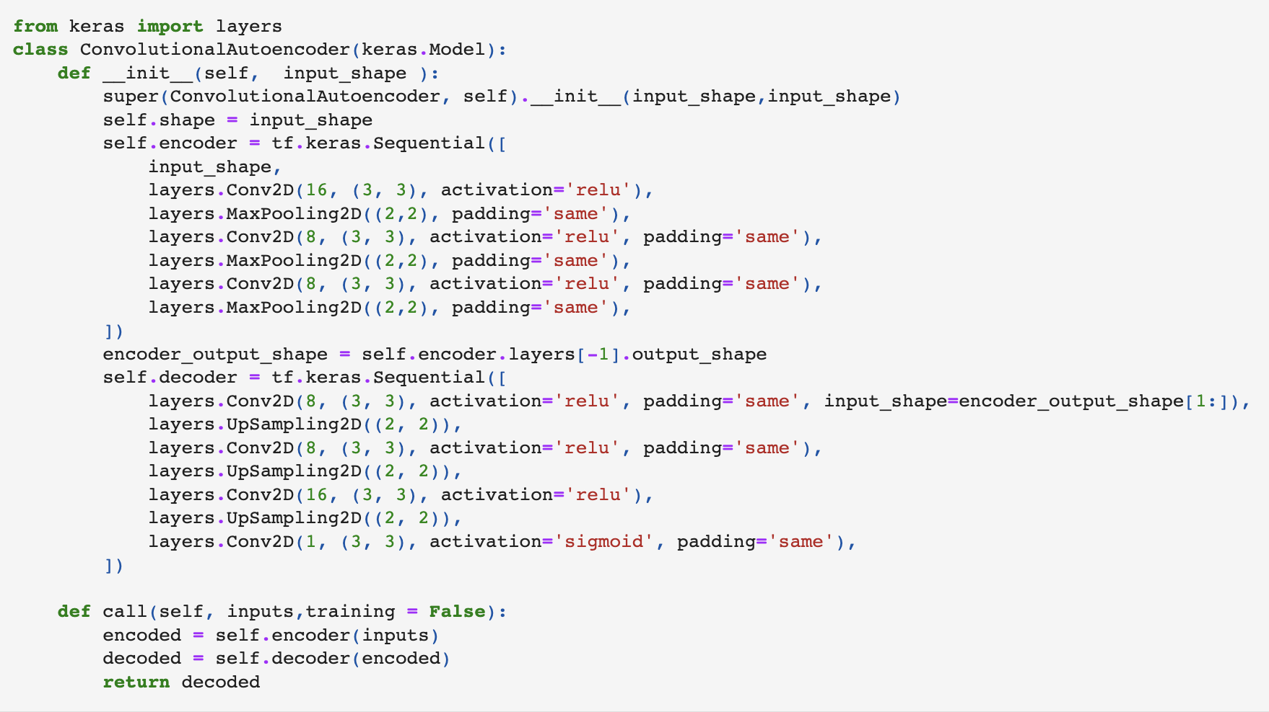

The other architecture tested was the Dense Autoencoder. In general, if the resolution of the input is too high it is not recommended this architecture, because the number of Connections in the Input and output layers are proportional to the combinations between the Input Layer and the First Layer, also last layer and the output layer.
For MNIST dataset is fine, once their dimensionality of each instance is 28x28x1 (28x28 grayscale) Input Layer Size 784 units, which is still manageable.
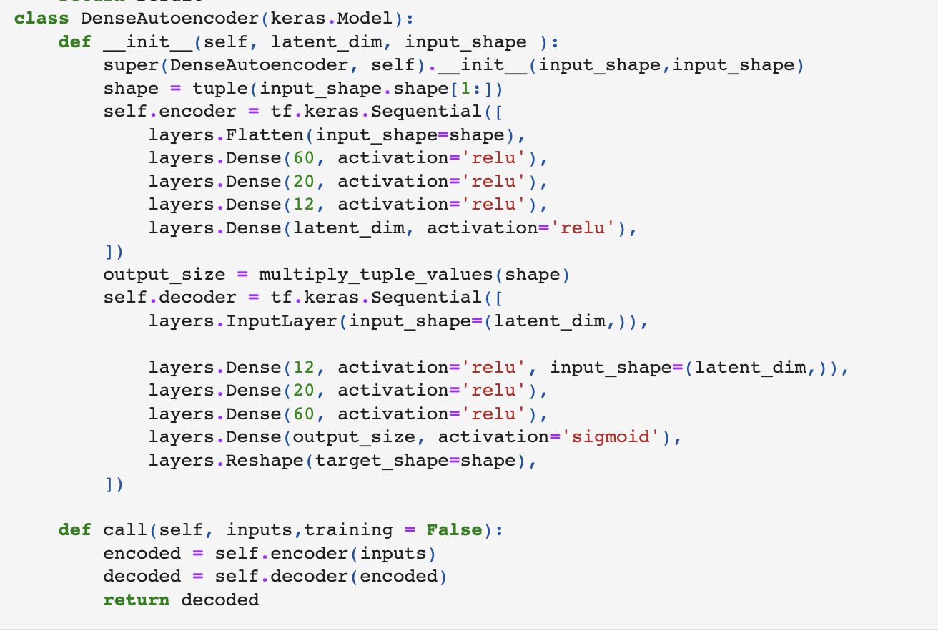
It has a symmetric layer between Encoding and Decoding, it is not at all an official rule, but it might help preserve the pattern of information between the layers. The Encoder has 4 Dense layers with relu, allowing non-linearity signal processing. In the experiment it was used the latent dimension of 2, because it was desired to plot the encoded points from test data into a scatterplot.
Then each architecture produces two models: one for traditional AE training, and another for CSC-AE training. Both models encode the Test dataset, and a comparison of the latent space produced by AE vs CSC-AE is made.
The experiments were built using TensorFlow, Keras, scikit-learn. As mentioned previously, PySpark and Hadoop were used as demonstration purpose manipulating the data, due the scope and viability of autoencoders for PySpark, and performance issues, it was decided to not implement solution end-to-end using Spark.
Each experiment had the following configuration: Early Stopping with patience=8, start_from_epoch=15.The max_epoch=100 for Convolution-AE and epoch=300 for the Dense-AE. These parameters were adjusted in this manner to have a reasonable time for training, and in case it is not improving the validation loss for 8 consecutive epochs stop, to avoid waste time in something that already converged.
The optimiser was the standard Adam with MSE as metric, which is quite good because it has a adaptative learning rating, and MSE penalize big deviations from desired value.
The goal of this process is to produce good latent space. In general, it is assessed how good are the features to execute another task. To be more specific, it was decided to measure how good is the separability of the classes in the latent space. A good latent space would be one which the regions of the classes don’t overlap each other.
After calculating the encoded values for each instance in test data, it is calculated the centroid of each class.
Then it uses a simple K-Nearest Neighbours Algorithm (KNN) trained with 1 centroid for each class, K=1, applying it for all test data.
If the latent space is good, it would provide good centroids close to all instances from same class, and far from all instances of other classes.
The quality of classification in the KNN would relate to the quality of the Latent Space produced by the respective autoencoder.
The metrics F1-Score macro and Rand Index. The F1Score is good because it incorporates in a single number all classes, precision and recall. The Rand Index is another good metric, because it is robust against permutation of the clusters. It would be more important if we were dealing with a complete unsupervised clustering, and then assessing the clusters detected against the original classes. It might be good for future works to explore other evaluation strategies.
Note for this Technique: the performance of the Decoder Layer is not the final objective, so the actual value of loss itself is also not important from a comparison perspective. Because it is being used only as a tool for finding a good encoder and latent space. But it is still important to be visualised to understand individually if the models learned properly, or underfit, or overfit.

Results
In this chapter it can be see the experiments results. As mentioned previously: Both techniques were tested against two architectures of Autoencoder (Convolutional Autoencoder, and Dense Autoencoder) resulting in 4 experiments.
Note in “Fig 1” and “Fig 2”, shows the learning in general for the Convolutional Architecture implemented didn’t work well. The loss function stuck in a plateau flat from the beginning, without progressing learning, certainly the Convolution-AE with the layers proposed for both techniques were not promising. It doesn’t pass 24 epochs in both cases.
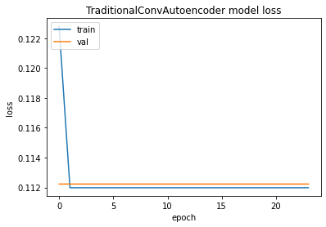
- Training Results for Traditional Conv-AE

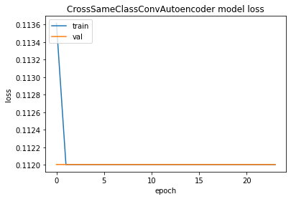
- Training Results for CSC Conv-AE

Differently from Conv-AE the Dense-AE training were effective in both techniques. It is possible to note in “Fig 3” and “Fig 4”, the loss function decrease gradually until converge to lower value. In Fig 3 the loss in the train data and validation data were quite close, indicating an good fitting. While in the Fig 4 it was also close, but the loss for train data were a little lower compared to validation data, it might be expected once we are training with the same instance as input output.
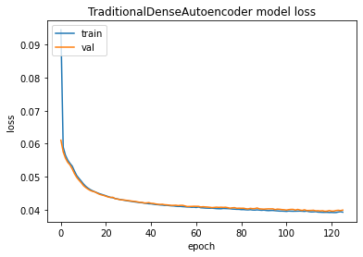
- Training Results for Traditional Dense-AE
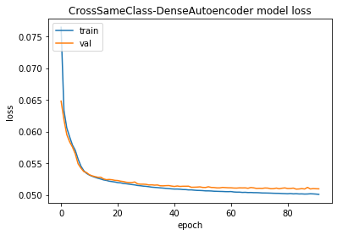
- Training Results for CSC Dense-AE

In “Fig 5” it is possible to see the metrics results, where in Conv-AE architecture both techniques demonstrate similar values for F1-Score and Rand Index. While in the Dense-AE the CSC technique displays clear better scores than traditional.

Model | F1-Score (Macro) | Rand Index
Traditional Conv-AE | 0.5820 | 0.8753
CSC-Conv-AE | 0.5606 | 0.8705
Traditional Dense-AE | 0.4319 | 0.8644
CSC-Dense-AE | 0.6113 | 0.8984
- Table with Evaluation Metrics on Test Data

2D Plot of Latent Space for Dense-AE
In order to visualize the latent space easily it was decided to use bi-dimensional encoding for Dense-AE. With that it is possible to compare in an intuitive manner the distributions of points between both techniques.

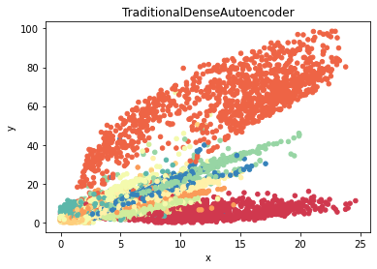
- Traditional Dense-AE Latent Space Scatter Plot

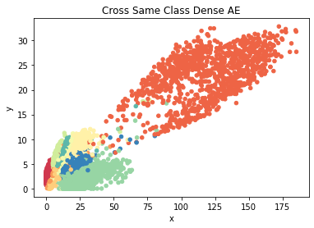
- CSC-Dense-AE Latent Space Scatter Plot
Note both models learned well and produced interesting latent space in Fig 6 and Fig 7, but the CSC-Dense-AE has much less overlapping, and more concentrated and rounded regions of points compared to the Traditional-Dense-AE, where the regions were more spread and stretched. The level of overlapping between classes in Traditional Dense-AE is bigger.

Discussions
The Convolutional-AE needs to be reviewed because the loss function over each epoch demonstrated poor learning. The result from this architecture is not reliable for CSC and Traditional. On the other hand, the Dense-AE architecture demonstrate an effective learning based in the behaviour of the loss function around each epoch. It makes the results for this architecture more solid in regarding the comparison between both techniques assessed in this paper.
Analysing the F1-Score and Rand Index it is possible to see the CSC Technique improve the separability if classes in the latent space, although it is important highlight it is necessary more experiments for giving a statistical significance to it, with a bigger range of architectures and datasets.
Additionally, note in the 2D scatter plot, it possible to see clearly improvements in the data distribution.
It is important to highlight that other methods for evaluating that doesn’t mandate hyper-circular regions might not penalise too much the Traditional-AE as it created some level of separability for a couple of classes but with a long-stretched regions. While the CSC-AE could make it more circular. Depending on the Task of the context once is separable even with a non-circular format might be good enough. But for some other tasks the circular format of the region might be important to have a good Euclidian space.

Conclusion
This project explored a proposed technique CSC-AE where differently from Traditional-AE it uses different signals from input and output. The CSC-AE demonstrated improvements in the latent space for Dense-AE architecture. The Conv-AE in general didn’t learn properly for both techniques Traditional-AE and CSC-AE. So, the latent space performance for Conv-AE could not be considered trustable on the experiment run.
The results are interesting, but it is necessary further experiments with multiples datasets and architectures to make statistically robust. Future works might explore deeper the topic and try to apply variants of the CSC-AE proposed in this paper, with other strategies to combine inputs and outputs of the same class. For instance, creating a parameter alpha where 0.0 is inputs is always equal to output (Traditional-AE) and 1.0 completely different (purely CSC-AE). In this paper it was used a non-parametric mix. Also, future studies could apply it in other problems such as Face Recognition, where the number of classes might be very large, and have testing classes completely different from training classes. The CSC-AE would be suitable for these cases. Furthermore, there are opportunity to analyse different methods for evaluating the AE such as applying other methods that do not impose centroids or circular regions of separability between classes.

References

- Apache Spark (2010). History | Apache Spark. [online] spark.apache.org. Available at: https://spark.apache.org/history.html# [Accessed 7 Oct. 2023].
- Borthakur, D. (2007). The Hadoop Distributed File System: Architecture and Design. [online] Available at: https://svn.apache.org/repos/asf/hadoop/common/tags/release-0.16.1/docs/hdfs_design.pdf [Accessed 7 Oct. 2023].
- Box, P., Van Der Maaten, L., Postma, E. and Van Den Herik, J. (2009). Tilburg centre for Creative Computing Dimensionality Reduction: A Comparative Review Dimensionality Reduction: A Comparative Review. [online] Available at: https://lvdmaaten.github.io/publications/papers/TR_Dimensionality_Reduction_Review_2009.pdf [Accessed 10 Dec. 2020].
- De Mauro, A., Greco, M. and Grimaldi, M. (2015). What is big data? A consensual definition and a review of key research topics. What is big data? A consensual definition and a review of key research topics. doi:https://doi.org/10.1063/1.4907823.
- Fei-Fei, L., Fergus, R. and Perona, P. (2006). One-Shot Learning of Object Categories. [online] Available at: https://www.cse.unr.edu/~bebis/CS773C/ObjectRecognition/Papers/Perona06.pdf [Accessed 6 Oct. 2023].
- Kan, M., Shan, S., Chang, H. and Chen, X. (2014). Stacked Progressive Auto-Encoders (SPAE) for Face Recognition Across Poses. [online] Available at: https://openaccess.thecvf.com/content_cvpr_2014/papers/Kan_Stacked_Progressive_Auto-Encoders_2014_CVPR_paper.pdf [Accessed 7 Oct. 2023].
- LeCun, Y. (2009). MNIST handwritten digit database, Yann LeCun, Corinna Cortes and Chris Burges. [online] Lecun.com. Available at: http://yann.lecun.com/exdb/mnist/.
- Makkie, M., Huang, H., Zhao, Y., Vasilakos, A.V. and Liu, T. (2019). Fast and scalable distributed deep convolutional autoencoder for fMRI big data analytics. Neurocomputing, 325, pp.20–30. doi:https://doi.org/10.1016/j.neucom.2018.09.066.
- Qiu, L., Li, S. and Sung, Y. (2021). 3D-DCDAE: Unsupervised Music Latent Representations Learning Method Based on a Deep 3D Convolutional Denoising Autoencoder for Music Genre Classification. Mathematics, 9(18), p.2274. doi:https://doi.org/10.3390/math9182274.
- Ramezani, M., Cong, W., Mahdavi, M., Kandemir, M. and Sivasubramaniam, A. (2022). LEARN LOCALLY, CORRECT GLOBALLY: A DISTRIBUTED ALGORITHM FOR TRAINING GRAPH NEURAL NETWORKS. [online] Available at: https://browse.arxiv.org/pdf/2111.08202.pdf [Accessed 6 Oct. 2023].
- Schroff, F. and Philbin, J. (2015). FaceNet: A Unified Embedding for Face Recognition and Clustering. [online] Available at: https://browse.arxiv.org/pdf/1503.03832.pdf [Accessed 7 Oct. 2023].
- Vasimuddin, Misra, S., Ma, G., Mohanty, R., Evangelos Georganas, Heinecke, A., Kalamkar, D.D., Ahmed, N.K. and Sasikanth Avancha (2021). DistGNN. doi:https://doi.org/10.1145/3458817.3480856.
- Zhu, X. (2005). Semi-Supervised Learning Literature Survey. [online] Available at: https://pages.cs.wisc.edu/~jerryzhu/pub/ssl_survey.pdf [Accessed 30 Oct. 2022].

